SOLANO COMMUNITY COLLEGE
MT 164, PROGRAMMABLE LOGIC CONTROLLERS
Spring, 2018

PLC PROGRAMMING LAB 6 - GAME SHOW LOGIC

Catharine Crayne
03/18/2018

OBJECTIVE:
- To write a ladder logic program based on a scenario of logic inputs.

Group Members:
N/a

MATERIALS: Micrologix 1100 Trainer Unit, wires, RSLinx and RSLogix software, laptop, crossover cable.

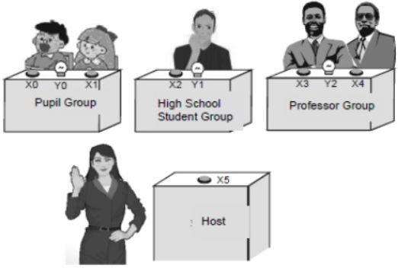
SAFETY AND EQUIPMENT NOTES:
- Turn off trainer when attaching wires

PROCEDURE:
Game Show Scenario:
- There are 3 groups participating in the quiz game: Pupils, HS student, and Solano professors. If they want to get the chance of answering the question from the host, they must press the answer button on their table first. Other groups’ pressing will be invalid if any group gets the chance successfully.
- There are 2 answer buttons for the pupil group and professor group and 1 answer button for the HS student. In order to give preferential treatment to the pupil group, Y0 will be ON if any one of X0 or X1 is pressed. However, in order to limit the professor group, Y2 will be ON when X3 and X4 are pressed at the same time. For the HS student, Y1 will be ON when X2 is pressed.
- If the host presses X5 (reset), Y0, Y1, and Y2 will all be OFF.
- Wire up 4 NO push-buttons, 1 switch (X5), and 3 lights on the PLC trainer and connect them to your PLC in appropriate locations.
- Write up a program that will satisfy the control requirements as written.
- Download the program and test it. Document it.
- Bonus: Make the output light flash on and off when the contestant group “buzzes in”.

RESULTS - DATA
Step 5: Snapshot of our program.

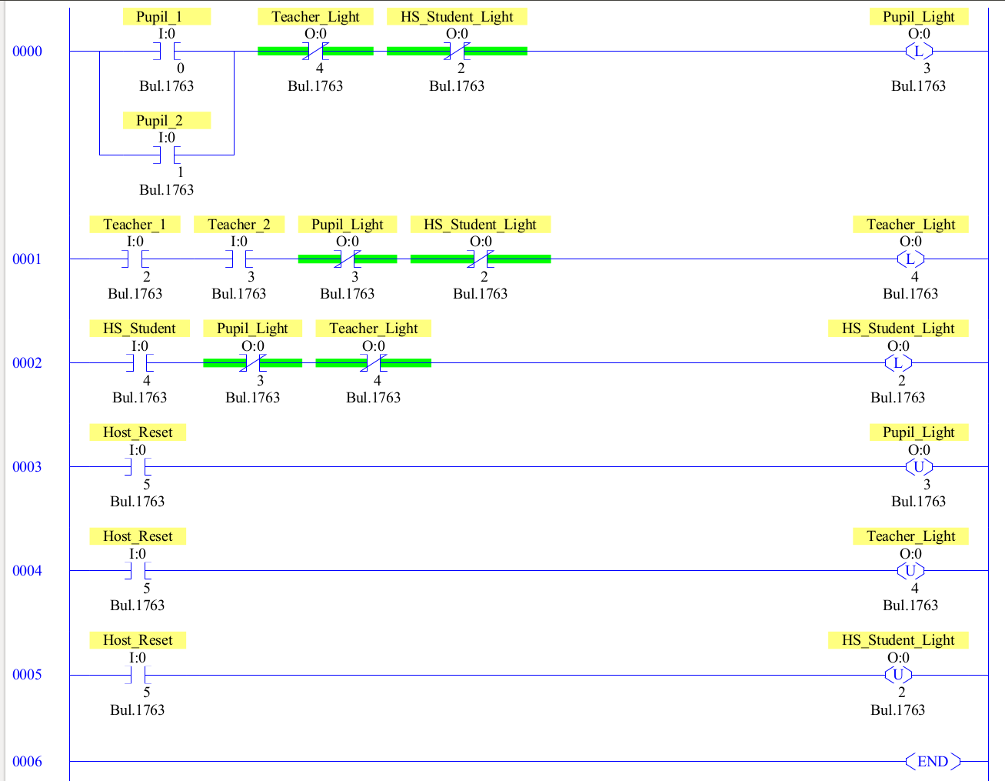

OBSERVATIONS
Step 4: Picture of my setup

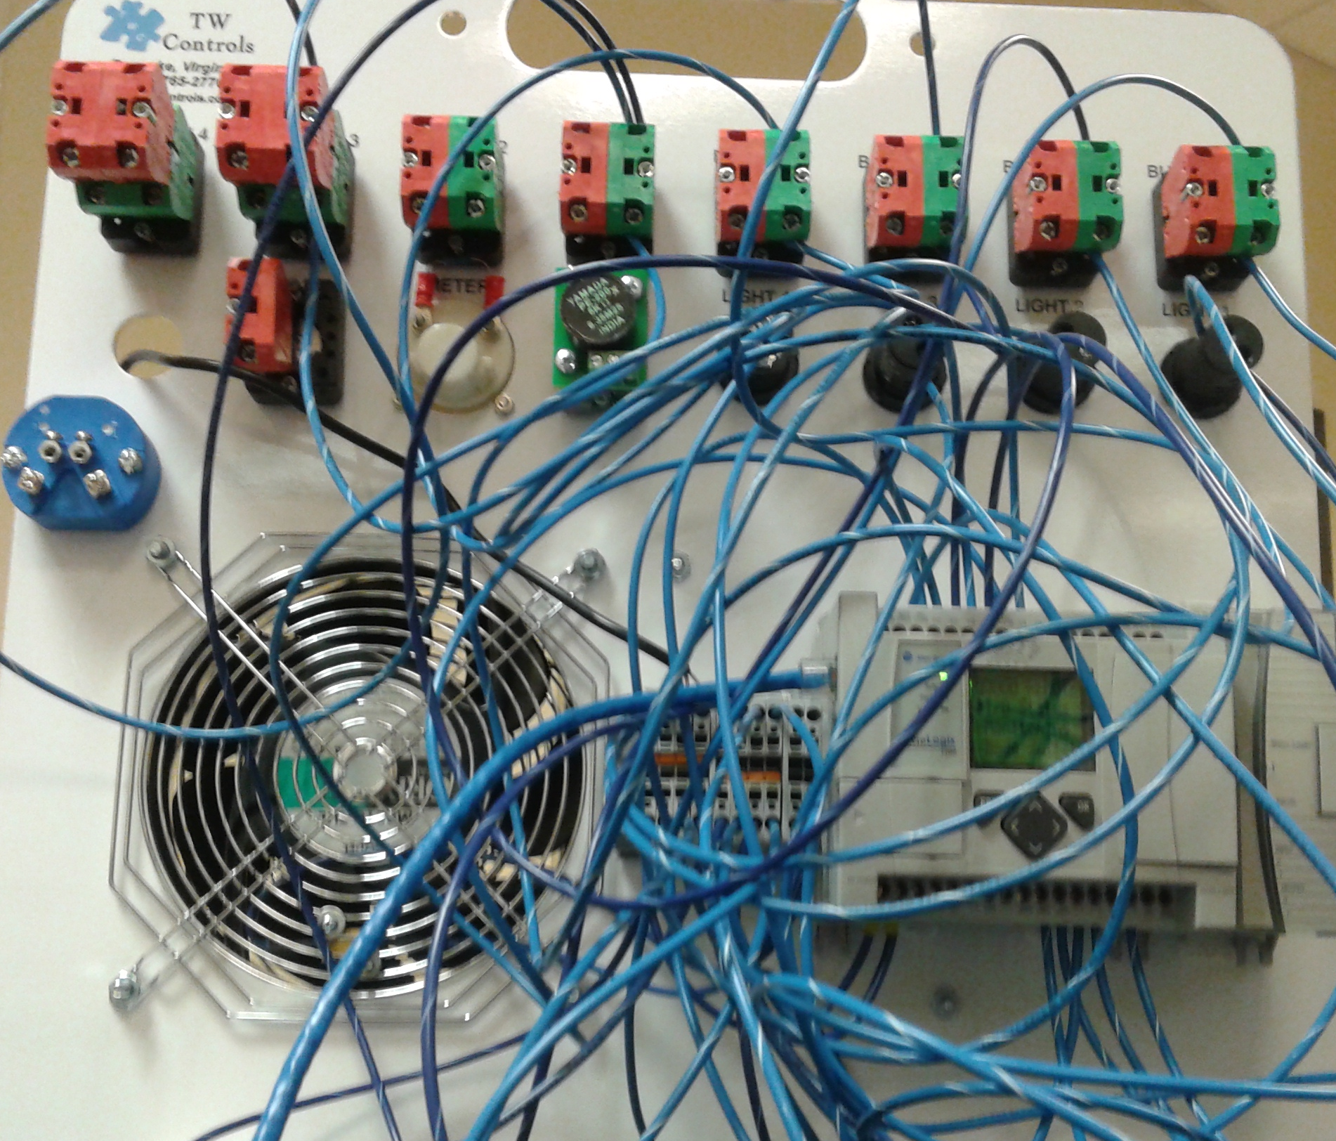

Step 6: Picture of my setup

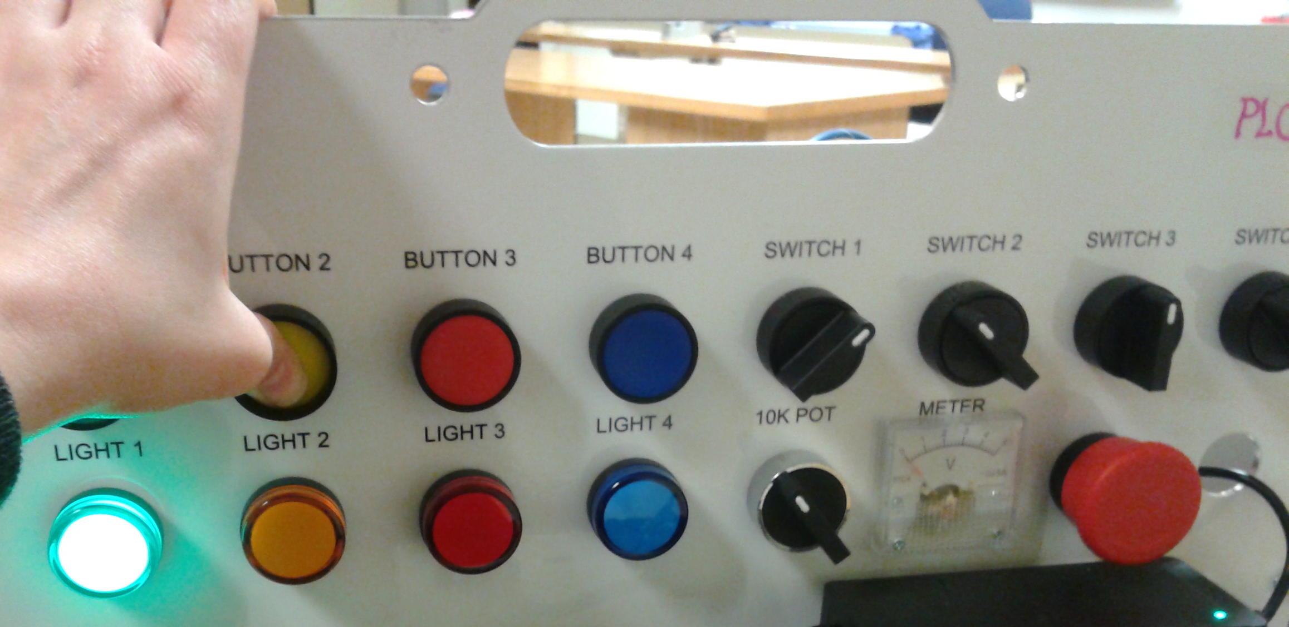

ANALYSIS QUESTIONS:
- Explain where an AND logic instruction is represented in this scenario?
The AND logic instruction is represented in the professor’s buzzer configuration because professor 1 AND professor 2 must push their buttons at the same time (and before the other teams) in order for their light to turn on.
- Explain where an OR logic instruction is represented in this scenario?
The OR logic instruction is represented in the Solano student team’s buzzer configuration because student 1 OR student 2 have to push their button for their light to turn on.
- What is the scan cycle time of your program?
The maximum scan time was 220ms. The ‘current’ scan time was 100ms, and the last scan time recorded was 140ms.
- Explain how this program may not work correctly if two contestant groups “buzz” in within the scan cycle time of the PLC.
If all contestants buzzed in at the same time, none of the lights would turn on because the output only evaluates to true if the other team’s input values are false.

